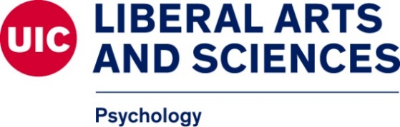

UIC Psychology Faculty Members (reviewing applicants for fall 2023 Admission)

Below you will find a list of all faculty members who will be reviewing applications for the upcoming admission cycle. This does not guarantee they will or are accepting new PhD students. We would encourage you to learn more about their research, labs, clinics, etc to determine if they may be a fit for you.

Brain and Cognitive Sciences
- Alex Demos
- Thomas Griffin
- Alex Keinath
- Eric Leshikar
- Michael Ragozzino
- Mitch Roitman
- Jamie Roitman
- Dennis Sparta
- Jennifer Wiley

Clinical Psychology
- Erin Berenz
- Ellen Herbener
- Loretta Hsueh
- Michael Meinzer
- Robin Mermelstein
- Brittany Rudd
- Margaret Wardle

Community Psychology
- Josefina Bañales
- Amanda Roy
- Kim Schonert-Reichl
- Jessica Shaw

Social & Personality Psychology
- Daniel Cervone
- Alex Demos
- Rebecca Littman
- Sohad Murrar
- Michael Pasek
- Tomas Stahl

