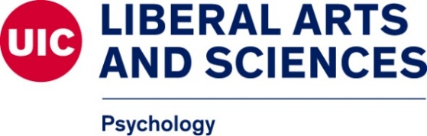

UIC Psychology Faculty (NOT reviewing applicants for fall 2023 Admission)

Below you will find a list of all faculty members who will NOT be reviewing applications for the upcoming admission cycle, nor will they be accepting new graduate students.

Brain and Cognitive Sciences
- Susan Goldman
- Pauline Maki
- Kara Morgan-Short

Clinical Psychology
- Marc Atkins
- Tory Eisenlohr-Moul
- Heidi Klumpp
- Katie Lawton
- Tara Mehta
- Jenna Szerszen
- Jasmine Searcy Pate
“As clinical supervisors, Drs. Jenna Szerszen, Katie Lawton, and Jasmin Searcy-Pate faculty provide supervision and mentorship to all students in the program. However, they do not have ongoing research labs; thus, they do not accept graduate students into the program/serve as research advisors.”

Community Psychology
- Katherine Zinsser

*Emeritus Faculty and Lecturers do NOT advise graduate students*

